Creacion de clase example app.cs

1

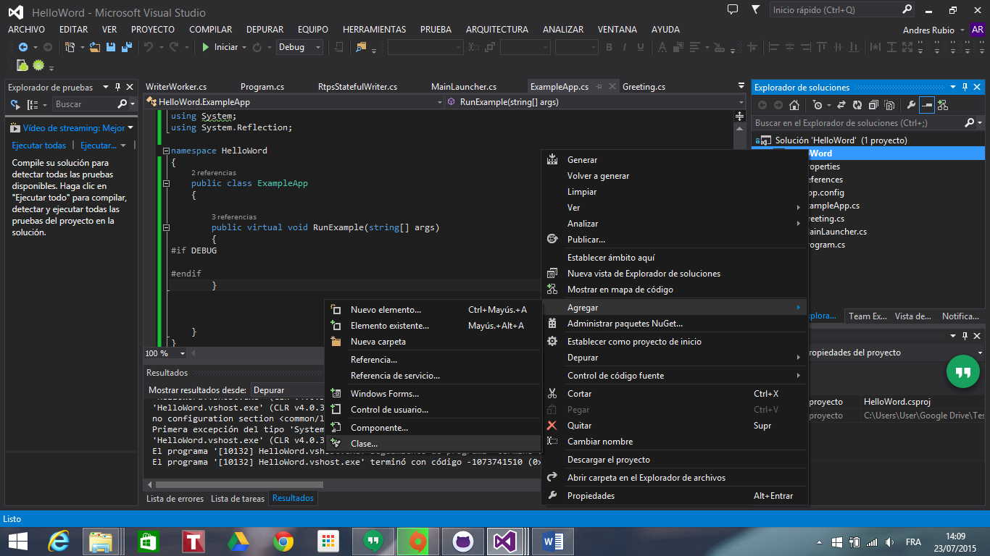

2

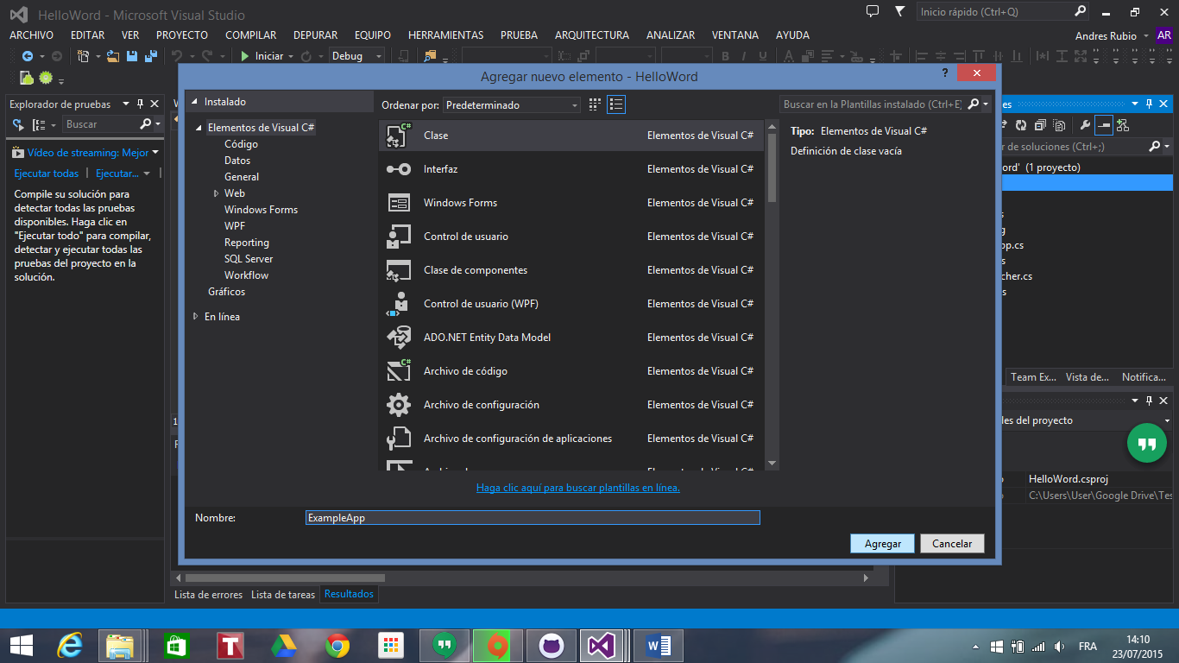

3

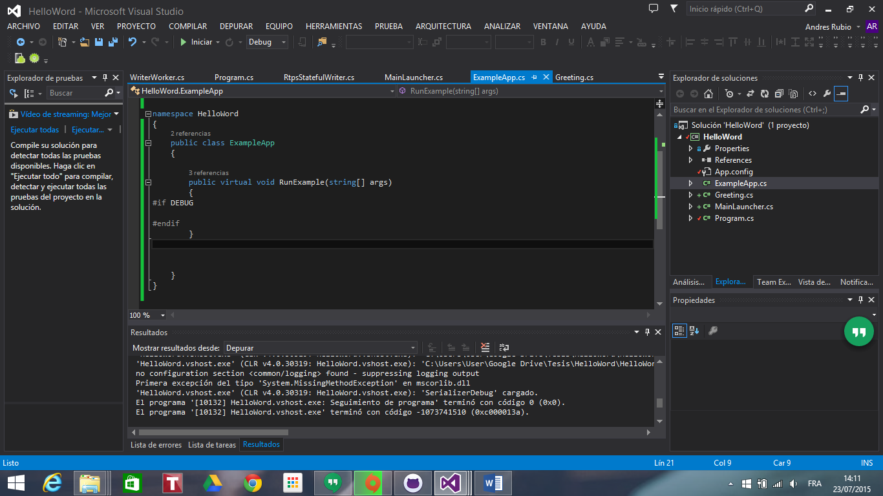

using System;

using System.Collections.Generic;

using System.Linq;

using System.Text;

using System.Threading.Tasks;

using log4net;

using System;

using System.Reflection;

4

Creacion greeting cs

1

2

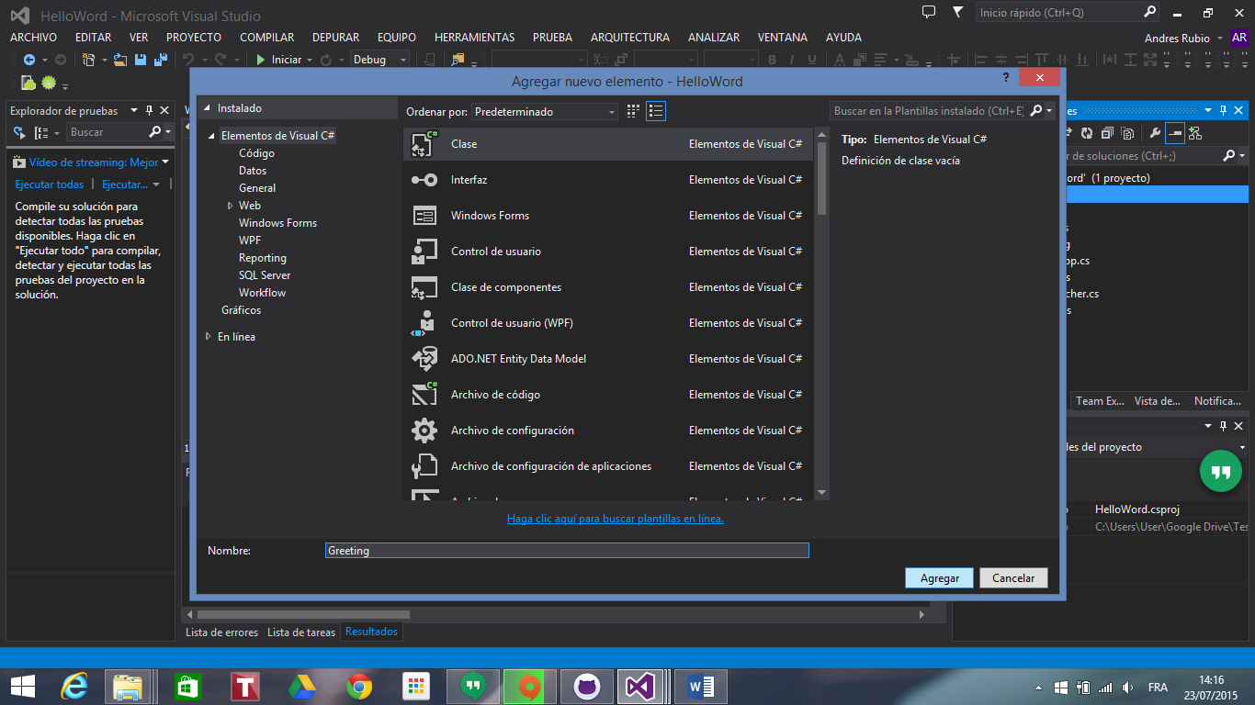

3

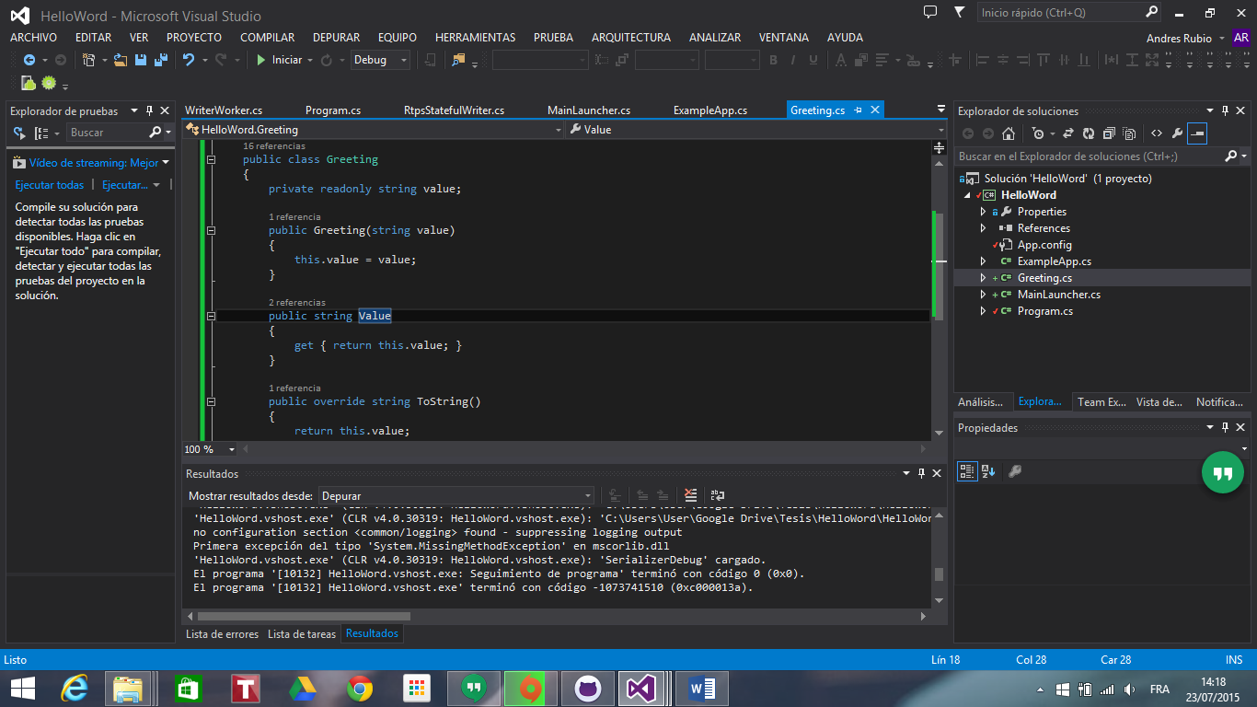

public class Greeting

{

private readonly string value;

public Greeting(string value)

{

this.value = value;

}

public string Value

{

get { return this.value; }

}

public override string ToString()

{

return this.value;

}

}

}

Creacion de la de la clase MainLauncher

1

1

2

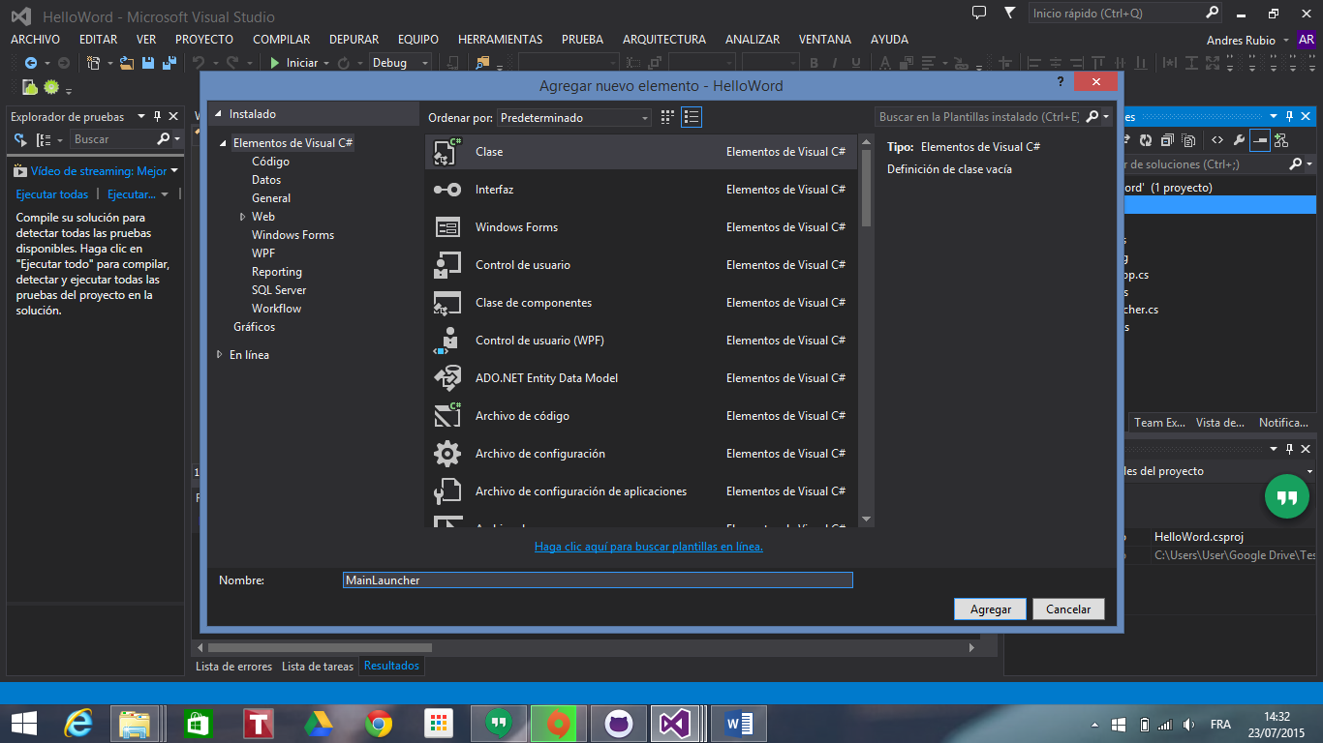

3

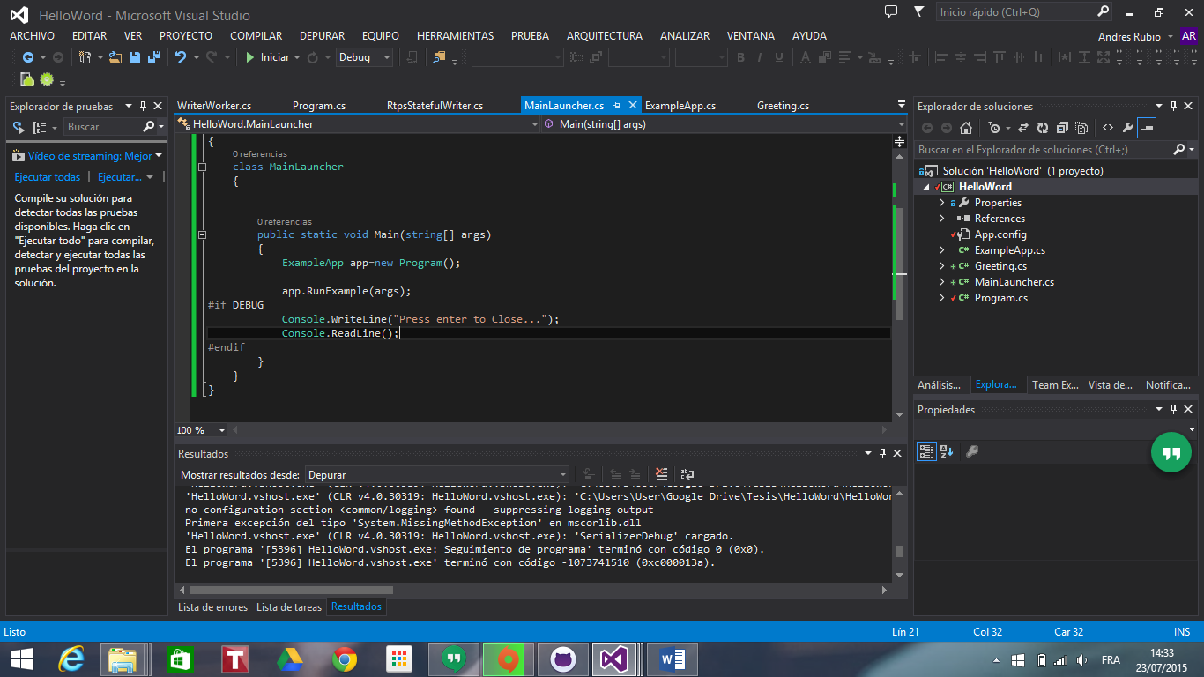

public static void Main(string[] args)

{

ExampleApp app=new Program();

app.RunExample(args);

#if DEBUG

Console.WriteLine("Press enter to Close...");

Console.ReadLine();